Active, Intelligent and Modified Atmosphere Packaging: A Model Technology for the Food Industry

P.Muredzi
School of Industrial Sciences and Technology
Harare Institute of Technology, Ganges Rd, Belvedere
Box BE 277, Harare, Zimbabwe
pmuredzi@hit.ac.zw

Abstract—. Active packaging, sometimes referred to as interactive or “smart” packaging, is intended to sense internal or external environmental change and to respond by changing its own properties or attributes and hence the internal package environment. The goal of active packaging, in conjunction with other food processing and packaging, is to enhance preservation of contained food and beverage products. This review paper discusses active, intelligent and modified atmosphere packaging as a model technology for the food industry and further reviewing the current status of the technology.
Keywords- Oxygen Scavengers, Emitters, Oxidation, CO₂ Absorbers,

Introduction
Packaging may be termed active when it performs some role other than providing an inert barrier to external conditions. Hotchkiss (1994) includes the term 'desired' when describing the role, and this is important in that it differentiates clearly between unwanted interactions and desired effects. This definition reflects the element of choice in how active packaging performs and the fact that it may play some single intended role and otherwise be similar to other packaging in the remainder of its properties.

These latter two aspects also reflect that active packaging is something that is designed to correct deficiencies which exist in passive packaging. A simple example of this situation is when a plastics package has adequate moisture barrier but an inadequate oxygen barrier. Active packaging solutions could be the inclusion of an oxygen scavenger, or an antimicrobial agent if microbial growth is the quality-limiting variable. Active packaging has developed as a series of responses to unrelated problems in maintenance of the quality and safety of foods. Accordingly a range of types of active packaging has been developed. Each of these has a range of descriptive terms. Horticultural produce has for some years now been packaged in 'smart films', and oxygen has been removed from package headspaces by oxygen scavengers, free-oxygen absorbers (FOAs) and deoxidisers. Carbon dioxide can be released by emitters or can be absorbed by getters, and microwaves can be controlled in packages by susceptors or shields (Sacharow and Schiffman, 1992). Regional differences in terminology are also seen. The terms 'freshness preservative' and 'functional' and 'avant garde' are also used to describe active packaging materials (Katsura, 1989; Louis and de Leiris, 1991). There has been a range of trade names for those packages where a generic form has not been coined, with the result that we have SmartCap (ZapatA - Advanced Oxygen Technologies) for closures for beer bottles and Oxyguard for Toyo Seikan Kaisha Ltd. for caps for similar use. Smart packages have been defined by Wagner (1989) as 'doing more than just offer protection. They interact with the product, and in some cases, actually respond to changes'. In this sense, most packaging media are active to some degree. However, there are forms of packaging which are clearly distinct subclasses. The term equilibrium modified atmosphere (EMA) packaging is used to distinguish the situation where the choice of the permeability ratio of oxygen/carbon dioxide determines whether respiring horticultural produce generates a viable gas atmosphere or not (Gill, 1990). Thus where modified atmosphere packaging (MAP) is used with processed foods and involves merely flushing with an initial gas mixture the packaging is not active. EMA packaging is one of the borders between active and passive packaging. If the physical interactions of a package with the food are removed we are left only with the chemical (and increasingly, biochemical) effects. Such a restriction is probably unduly strict and in time we should expect to see further subdivision of active packaging to take account of whether 'activity' is a property of the packaging material itself or of inserts within the package. We are beginning to see reference to the benefits of active packaging in the popular press with reference to 'packaging that is niftier and cooks your food' and 'Hi-Tech' packaging (Sprout, 1994). The active packaging includes susceptors and reflectors in microwaveable packs as well as horticultural smart films that absorb ethylene. These are described together with temperature sensitive labels that help determine when food is cooked, i.e. 'doneness indicators'. There are other areas of packaging developing concurrently and there are areas of overlap with active packaging as noted with MAP above. Probably the closest area is Intelligent Packaging, a grouping of technologies defined in the CEST publication by Summers (1992) as 'an integral component or inherent property of a pack, product or pack/product configuration which confers intelligence appropriate to the function and use of the product itself. This grouping covers the area of product identity, authenticity, traceability, tamper evidence, theft protection, and quality as indicated by time temperature indicators. The latter was originally included by Labuza (1987) in his seminal review of active packaging. Time-temperature indicators also fit the definition of active packaging given above; they play a role in defining the steps that need to be taken to ensure the quality and safety of the packaged food. A somewhat related field of packaging which so far has fallen between the two definitions is that of gas composition indicators. To date they have been used in the form of tablets to indicate when oxygen scavenging sachets have achieved their purpose (Anon, undated). There have been steady efforts made for several years to produce oxygen-indicating printing inks but thus far, like the pellets, these indicators largely change colour at oxygen levels below 0.1%. The description of this field as interactive packaging is also seen. There is some benefit in such a description as it links desired and undesired interactions of foods and their packaging, such as flavour scalping (Hirose et al, 1989).

DESCRIPTION
Active packaging, sometimes referred to as interactive or “smart” packaging, is intended to sense internal or external environmental change and to respond by changing its own properties or attributes and hence the internal package environment. Active packaging has been considered a component of the packaging discipline for several decades or since the first inclusion of desiccants in dry product packages. In their own moisture-permeable sachets, desiccants absorb water vapour from the contained product and from the package headspace, and absorb any water vapour that enters by permeation or transmission through the package structure. As separate entities within packages, active packaging sachets, pouches, patches, coupons, labels, etc., are not often integral to the package—a semantic differentiation. Desiccant pouches are widely used in the packaging of hardware and metal goods. The best-known and most widely used active packaging technologies for foods today are those engineered to remove oxygen from the interior package environment. Oxygen scavengers reduce oxidative effects in the contained product. Most oxygen scavengers in commercial use today are gas-permeable, flexible sachets containing reduced iron (i.e., iron not in the fully oxidized state) particles inserted into food and other packages from which air is initially removed by vacuum or by flushing with inert gas. During the last two decades of the twentieth century, commercial incorporation of oxygen-removal materials directly into a package structure occurred with varying results. Several applications for beer and juice bottles became commercial in 2000. The goal of active packaging, in conjunction with other food processing and packaging, is to enhance preservation of contained food and beverage products. For example, to optimize the effects of oxygen scavenging, oxygen should first be removed from the product during processing and packaging operations. The oxygen must also be thoroughly removed from the package interior and the package materials, and the package structure, including materials and closure, must be barriers to further oxygen entry. In other words, oxygen scavenging complements good oxygen-control practices. In addition, oxygen is certainly not the only vector that can influence the quality of the contained food. For example, moisture gain or loss, light, nonoxidative reactions, microbiological growth, and enzymatic activity may all, individually or collectively, be involved in food-product deterioration. Worldwide development efforts devoted to oxygen removal have indicated that analogous efforts by the same and parallel research teams continue to be applied to oxygen scavenging and are being studied for other active packaging forms. Michael Rooney’s book, Active Food Packaging (Rooney, 1995), coalesced some of the many known active packaging concepts for foods into a single volume. This book did not, however, probe deeply into some of the more promising technologies that have been proposed and have entered the marketplace, including antimicrobial films, carbon dioxide emitters, aroma emitters, and odour absorbers. Each of these is discussed or referred to in this text. On review of the commercial situation in the United States, and especially the application of oxygen-scavenging compounds into the walls of beer bottles and processed-meat packages, the reasons for the notable paucities in the Rooney book become apparent. Although reviewed and referenced in commercial contexts, definitive scientific documentation and publications are lacking, unsubstantiated, or unclear. Descriptions of plastic bottle wall oxygen scavenging appear only in the patent literature, which does not, of course, detail specifics. The 1999 and 2000 George O. Schroeder conferences, “Oxygen Absorbers: 2000 and Beyond” and “Oxygen Absorbers: 2001 and Beyond” (Anonymous, 1999, 2000) set out to probe the expanding realm of oxygen- removal mechanisms. The presentations offered excellent reviews of historical and contemporary technologies and scientific studies but did not elucidate on the intriguing, but still largely proprietary, industrial world of oxygen scavenging. High-gas-permeability films, including some that increase their oxygen permeability with increasing temperature, are used for packaging fresh-cut produce. Use of these temperature-sensitive package materials is expected to increase because the technology developer has acquired a fresh produce packager who, of course, uses the technology in its package materials. Carbon dioxide and ethylene scavengers for modified-atmosphere (MA) or, more precisely, controlled-atmosphere (CA) food preservation are common in large bulk shipments. Carbon dioxide emitters to suppress microbiological growth have experienced limited success in modified-atmosphere packaging (MAP). Ethylene scavengers are among the more successful commercial active packaging technologies in the fresh-fruit bulk-shipment category. Odours generated or captured within closed food packages are undesirable, and their obviation has been a research topic for years. Odor removers incorporated into packaging are increasingly important in some classes of food packaging. Antioxidants and oxygen interceptors incorporated into package materials, such as tocopherols (vitamin E), have emerged in recent years and are increasingly employed to combat odours generated in plastic processing. Tocopherols, which are non-volatile, have not replaced volatile butylated hydroxyanisole/ butylated hydroxytoluene (BHA/BHT) which migrate into foods in product antioxidant applications, but they appear to be new antioxidants of choice for mitigating the effects of oxygen. Entities such as oxygen scavengers/interceptors react with oxygen to form new compounds. Oxygen absorbers may remove oxygen by any means, including physical. Antioxidants react with free radicals and peroxides to retard or block the actual oxidation reactions. Sequestering agents tie up inorganic catalysts that might otherwise accelerate adverse oxidative reactions. Members of the food technology and packaging communities have long regarded package materials as an ideal reservoir and delivery vehicle for antimicrobial compounds. For many years, sorbic acid has been incorporated sparingly on the interior of package structures as an antimycotic in a limited number of dry food packages. The obvious benefits of sorbic acid as a mold and yeast inhibitor have been one foundation by which numerous other antimicrobial agents have found their way into food package materials. Unfortunately, most antimicrobial agents also exhibit toxicity when they enter the food from the package and would be consumed as part of the food. Thus, actual commercialization has been proceeding slowly, except in Japan where several compounds have been reported to function effectively as antimicrobials in commercial packages. As with oxygen scavengers, the major technological and commercial successes for antimicrobials have been achieved by Japanese organizations for packaging Japanese products in Japan. Nevertheless, the concept of integrating microbistatic and microbicidal materials and plastic packaging has been very attractive. Numerous attempts have been and are being made to translate favourable laboratory results into safe and effective commercial food packaging. The growing list of successes in active packaging beyond oxygen scavenging has been noted by the food-packaging community

GENERAL ANALYSIS
Active packaging has developed as a series of topics which are related only because they involve the package influencing the environment of the food. The literature in this field consists very largely of patent applications, technical leaflets and reviews. The latter have often been presented at conferences where specialised audiences have been able to take up the ideas presented. Reports of academic scientific investigation have been limited largely to occasional assessments of the appropriateness of some of these technologies. The literature in this field is therefore discussed in terms of the reviews. Sneller (1986) reported on the impact of smart films on controlled atmosphere packaging although the first broadly based reviews were presented in Iceland and Australia in 1987 (Labuza, 1987; Rooney, 1987). The first use of the term active packaging was proposed at that time by Labuza, who defined active packaging as a range of technologies, some of which now represent the borderlines between active, 'intelligent', and modified-atmosphere packaging (Labuza and Breene, 1989). The essential features of these 'freshness enhancers' have been summarised in a short review by Sacharow (1988). Katsura (1989) reviewed the range of functional packaging materials which had been commercialised with particular reference to Japan. He demonstrated the attention that had been paid to freshness preservative packaging. Wagner (1989) summarised the range of smart packages and emphasised the role of microwaveable-food packaging. Rooney (1989a,b; 1990) concentrated on chemical effects, particularly oxygen scavenging. The role of oxygen scavengers in maintaining the benefits of MAP for processed foods was reviewed by Smith et al. (1990) following their own research into suppression of microbial growth The International Conference on Modified Atmosphere Packaging at Stratford-upon-Avon (UK) in 1990 organised by the Campden Food and Drink Research Association included several reviews relating to active packaging. Louis described several innovative active packages which generated modified atmospheres. Abe gave the first comprehensive quantitative assessment of the impact of active packaging. He estimated the market size for each of the broad classes of such packaging systems. His review reveals that around 6.7 billion oxygen-scavenging sachets and 70 million ethanol-generating sachets were manufactured in Japan in both 1989 and 1990. The estimated market for films containing mineral powders was only 1000 tonnes in 1989 with 40% of consumption as home use. The review by Robertson (1991) emphasised the application of active packaging to processed foods. The emphasis was placed on crown seals for bottled beer, oxygen-scavenging plastics films and microwave susceptors. The use of the term active packaging rather than smart films was noted by that reviewer and by Sacharow (1991) who also noted the use of sachets of potassium permanganate in silica gel for ethylene removal in produce packs. By this time the claimed benefits of freshness preservation technologies for horticultural products were being examined critically, especially in Japan. Ishitani (1993a,b) surveyed the number of patent applications for this purpose from 1984 to 1989. Over the first two years the annual rate was around 35 applications. This increased to a peak rate of 220 per annum in the second half of 1987 before dropping to around 60 per annum in 1989. It was noted that initial developments were directed at the needs for low temperature maintenance and moisture control. The boom in 1987 was the consequence of the attention being paid to gas composition control and ethylene removal. By 1989 gas composition was the main object of developments but moisture control and coating methods were also important. Ishitani (1993a) observed two factors that led to much rethinking. These were the lack of data on the requirements of produce and doubts about the capacity of powder-filled plastics to remove enough ethylene. More recent developments have been focused on ethylene removal at high humidities and on matching gas composition and temperature to the requirements of enzymic systems of plants. Several recent books on MAP have included discussion of the gas-packaging requirements for horticultural produce as well those for some processed foods (Ooraikul, 1993; Parry, 1993). The environmental aspects of active packaging have not been considered to any great extent in reviews to date. Rooney (1991) addressed some issues drawing attention to the need to consider the nature of the packaging which can be replaced by these new technologies. The current state of development and commercial application of active packaging has been reviewed in three papers at the symposium Interaction: Foods - Food Packaging Material held in Sweden in June 1994. Miltz et al (1994) reviewed the field in general, Ishitani (1994) concentrated on Japanese developments, especially antimicrobial films, Day (1994) concentrated on fresh produce and Guilbert and Gontard (1994) focused on edible and biodegradable packaging. Several posters described original research and that of Paik described photo processing of a film surface to generate antimicrobial properties. Perdue (1993) has briefly reviewed antimicrobial packaging from the viewpoint of the Cryovac Division of W.R. Grace Company and presents a somewhat pessimistic picture.

ACTUALISATION

Reviewing the Current Status of the Technology

The range of active packaging is so broad that, with further development, many of these technologies will be able to aid in the preservation and quality retention of commercially processed and packaged food (Tables 1, 2, and 3). The challenge is that the numbers of different active packaging proposals and commercialisations from around the world are very large. Further, many of these claims are often difficult to comprehend. Perhaps in the future, some of these active packaging concepts may be further developed into systems that are or would be applicable in the United States and Europe.

Table 1: Types of Active Packaging Systems with Mode of Action and Representative Manufacturers (Excluding Oxygen Scavengers). Adapted from Floros et al., 1997.

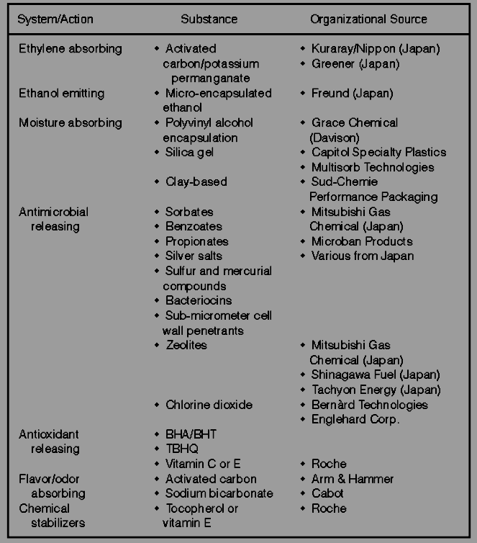

Table 2: Selected Patents on Various Active Packaging Technologies: CO₂ Absorbers / Emitters, Ethylene Absorbers, and Ethanol Generators (Excluding Oxygen Scavengers).

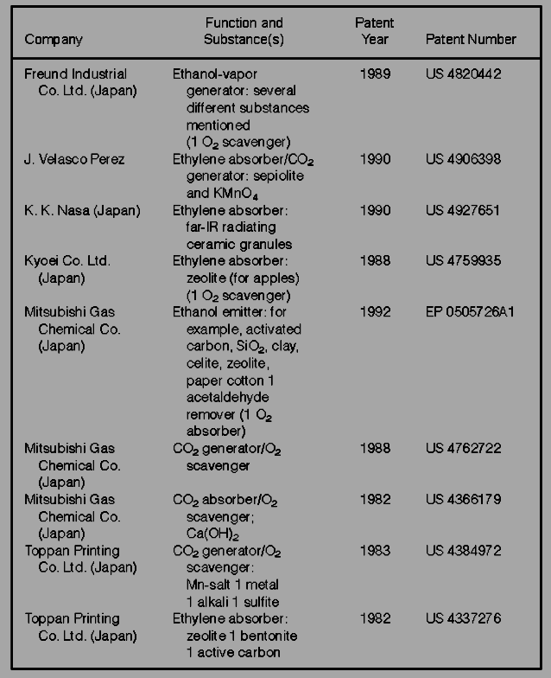

Table 3: Current and Potential Future Applications of Active Packaging Technologies
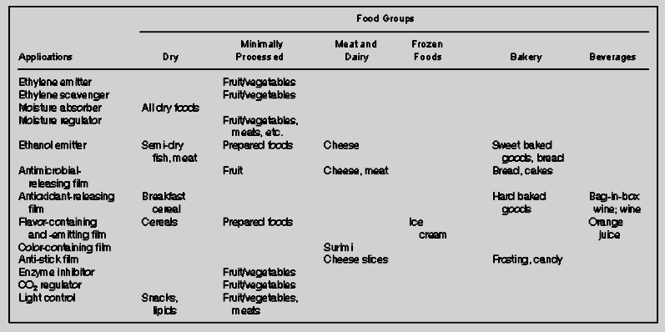

(Excluding Oxygen Scavengers)

DISCUSSION

Active packaging is still developing as a collection of niche markets so it is not surprising that a diverse range of packages active in the physical and chemical sense are either proposed or commercially available. Early among these was the use of the reaction of lime with water to generate heat for self heating cans of sake (Katsura, 1989). The Verifrais process for meat packaging uses the reaction of organic acid with bicarbonate to produce carbon dioxide in response to meat drip in foam trays. The carbon dioxide released helps to suppress microbial growth. Some properties of foods which can be addressed by active packaging are summarised in Figure 1. These properties are grouped depending upon whether they are designed to sustain living foods, suppress insect or microbial life in any foods, prevent oxidative attack on food constituents, retain flavour, or facilitate serving of the food for consumption.
Active packaging can be seen in one sense as a means of maintaining the optimum conditions to which a food was exposed at the immediately preceding step in its handling or processing. Passive packaging has been used in an effort to minimise the deleterious effects of a limited number of external variables such as oxygen, water, light, dust microorganisms, rodents and to some extent, heat. Hence, active packaging has the potential to continue some aspects of the processing operation or to maintain chosen variables at particular levels.

This aspect of active packaging is a unifying theme and crosses the border between foods such as plant produce, and processed foods, including those thermally processed. A second aspect of active packaging is that it can be involved in the preparation of the food for consumption. This includes aspects of temperature modification either for organoleptic or food safety purposes. These properties therefore include heating, cooling and foaming.

Figure 1: Properties of foods amenable to active packaging.

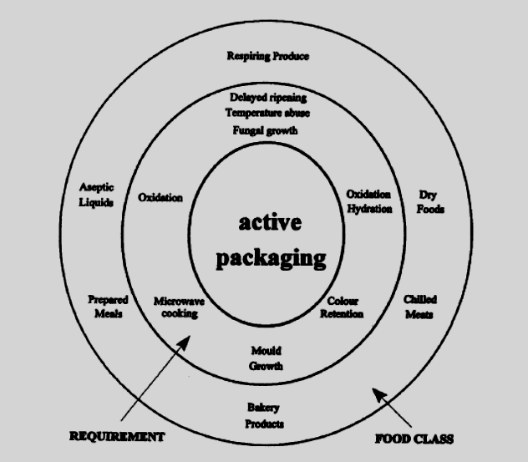

Non-processed, respiring food such as agricultural and horticultural produce, fish, crustaceans and other seafood can be stored and/or shipped over long distances provided the respiration requirements are satisfied under controlled temperature conditions. Thus if the packaging can regulate the supply of oxygen to the animal or produce such that a minimum respiration rate can be sustained, an enhanced period of prime-quality life can often be achieved. In plant products the optimum oxygen concentration of the environment varies with the species, and levels down to 1% may be possible without inducing anaerobic respiration (Labuza and Breene, 1989). The generation of elevated levels of carbon dioxide to suppress ethylene synthesis and to suppress microbial action can be achieved by selection of plastics films of appropriate permeabilities. However, achievement of the optimum balance of oxygen and carbon dioxide concentrations by use of plastics films alone is frequently impossible, particularly as allowance must be made for temperature abuse. It is possible to predict the potential packaging requirements for horticultural produce by modelling the properties of the food and the packaging film. There have been several reports published on approaches to modelling such systems, and they have been compared by Solomos (1994), who has tabulated the characteristics provided for in each of the models. This form of packaging is commonly termed modified atmosphere packaging (MAP) or more appropriately equilibrium modified atmosphere (EMA) packaging. EMA packaging involving selection of polymer films is, as mentioned previously, the borderline between active and passive packaging. Several approaches to overcoming the limitations of these films have been reported. One which is still in its infancy is the use of liquid crystal polymers which undergo a phase change at a characteristic temperature. The permeability of the polymer to oxygen sharply increases as this temperature is exceeded, thus providing the oxygen necessary to prevent packaged horticultural produce from switching from aerobic to anaerobic respiration. The present state of the art is not sufficiently advanced to cover EMA films which match produce over a wide temperature range, but research has opened up this possibility. An alternative involves pores in portions of a package which open when the temperature exceeds a precisely set value. This has been achieved by filling pores in a patch on a package with a wax which melts appropriately (Cameron and Patterson, 1992). This wax, when liquid, is drawn away by a wick such as a microporous film to leave the pore open to gas exchange. This type of high-temperature emergency valve is applicable to packages over a wide range of sizes. Microporous patches are already used commercially on retail trays of some fruit. The use of pores in packaging materials to actually balance the atmosphere in packages of respiring fruit has been the subject of some research and a large amount of marketing. Several forms of crushed rock, coral and synthetic zeolites have been incorporated into extruded film but there has been very little disinterested scientific evaluation done. Such films extend the range of gas permeability values of the commodity films in current use. Some results for P-Plus, a porous film currently manufactured by Sidlaw Packaging, Bristol (UK), have been presented (Gill, 1990). Predictive research and some experimental verification of the effects of single pores in produce packages have been reported (Mannapperuma and Singh, 1994). The effects of changes in temperature on gas composition need to be evaluated. Extension of the post-harvest life of fruits and vegetables requires more than EMA packaging. The water relations between the horticultural foodstuff and its atmosphere need to be balanced both to prevent dehydration and to avoid condensation induced by temperature abuse. Since the RH of such packages exceeds 95%, a temperature drop from 12°C to 110 ⁰C at the pack surface can cause condensation. Microporous pads containing inorganic salts have been shown to buffer the water vapour pressure (Shirazi and Cameron, 1992). Some of these are used commercially in the USA and Japan but others are close to commercial development. There have been some patents directed towards use of combination effects in active packaging for horticultural produce. Thus there have been patents of combination CO₂ emitter/water vapour absorbers and otherwise similar compositions but including an oxygen scavenger as well. This would bring the advantages of reducing the time the packaged horticultural product is subjected to high oxygen levels and inhibiting the onset of ripening, particularly with climacteric fruit. The rapid oxygen scavenger films of Rooney (1982) and Maloba (1994) could be suitable for this purpose if they met with regulatory requirements. Other approaches to enhancing the storage life of horticultural produce have been directed towards removing ethylene produced by ripening fruits and vegetables. Since ethylene is both produced by ripening fruits and triggers their ripening it is essential to prevent those fruits which are further along the ripening process from triggering ripening of others in the same enclosed space. Injured fruits are a particular problem in this regard and this emphasises the need for strict quality control in EMA packaging. The isolation of packages containing fruit rapidly generating ethylene may be the appropriate target of technologies for ethylene removal. The challenge appears to be to provide independently verifiable chemical processes which function satisfactorily to remove ethylene at physiologically significant concentrations in packages under conditions of high humidity and possibly in the presence of condensation. Since the quantities of ethylene are tiny, the cost should not be the major obstacle to commercial development. Produce packages normally have large headspaces so both sachet and packaging film scavengers should prove acceptable. Several other 'freshness enhancing' properties have been claimed for some commercial films but the processes occurring therein have not been clarified. Besides horticultural produce and living seafood which are meant to be kept alive during transportation, there is the very important field of chilled meats which retain muscular respiration for some hours or days post slaughter. While beef, for instance, is capable of oxygen scavenging by muscle respiration for a few days at meat works chiller temperatures of-1°C to 1°C, it is no longer capable of doing so for the remainder of the desired storage period, usually 4-8 weeks. Lactic acid bacteria lower the pH and suppress the growth of Bronchothrix thermosphacta and Pseudomonas spp. and other species. There is scope for oxygen scavenging films in bag construction to prevent oxygen permeation and for lactic-acid-releasing films to enhance this effect in some cases. The removal of residual oxygen from MAP meat packs by oxygen scavengers would increase security and decrease the need for slow, sophisticated packaging processes in this case. The carbon dioxide levels are normally very high (> 99%), as in the Captech process (Gill, 1989), so oxygen scavengers would need to operate wet in this environment. An additional definition of active packaging specific to horticultural produce distinguishes between passive and active modified atmosphere packaging (Zagory and Kader, 1988). The passive form which we are considering as EMA involves choice of the packaging material for its ratio of permeabilities to O2 and CO₂ as well as for their absolute values. Active MAP has been defined as gas atmosphere replacement by flushing or evacuation-back flushing, although the option of adding other active agents has also been considered (Kader, Zagory and Kerbel, 1989). Modified atmosphere packaging of non-living foods is now a mature area of research and has resulted in filling significant niche markets, particularly in the bakery, cheese and fresh pasta areas. Fresh pasta, which has been a recent success internationally, is dependent on MAP (Castelvetri, 1990). The growth of moulds, while suppressed by elevated carbon dioxide concentrations, is not uniformly affected across the range of species. Low levels of oxygen can in some cases support some species of mould, particularly as carbon dioxide is lost by permeation of packaging films. There is a need to remove most residual oxygen which may reach more than 1% when flushing is used without prior evacuation. Oxygen concentrations below 0.1% are desirable especially when cut surfaces are exposed, as in pizza-type cheeses and some MAP meats. Besides mould growth, chemical effects such as oxidative attack on colours in preserved meats (Andersen and Rasmussen, 1992), nutrient degradation such as vitamin C loss which can result in browning products (Waletzko and Labuza, 1976), and rancidity generation in fats and oils (Nakamura and Hoshino, 1983) can be prevented or minimised by use of oxygen scavengers. One benefit to researchers of oxygen absorbers is allowing ultimate effects of near-zero oxygen content atmospheres to be evaluated so that prediction of shelf-lives under other less perfect conditions can be more firmly based. Although initial development, and current commercial practice, is based on sachets of scavengers inserted into packs, much recent research and development has been directed towards scavenging polymers which can address problems with oxidisable liquids such as beer, wines, fruit juices and other beverages. Polymers, because of their ease of melt formation, can take the scavenging capacity to localised areas such as closures and to areas of close contact of product and package as found with meats, cheeses and wet foods generally.
The ability of polymers to act where there is close contact opens the way to provide a variety of food additives via a diffusive mechanism. This includes antimicrobial action (Halek and Garg, 1988) or antioxidant (Han et al, 1987) effects. To date, the use of such packaging has been restricted to controlled release of antioxidant into cereal products (Miltz et aL, 1989). The benefit of slow release of antimicrobial agents and antioxidants is the potential for maintenance of the requisite high concentration at wet food surfaces. This applies especially to high-water-content foods in which diffusion from the surface into the bulk can deplete surface concentrations (Torres et aL, 1985). This effect has been noted by Smith et aL (1990) who investigated the effectiveness of ethanol-emitting sachets on the growth of Sacchawmyces cerevisiae on apple turnovers. For active packaging to fulfil a useful role in this field it will be necessary for it to provide controllable, slow release matched to the needs of the food. Water-triggered sachets of silica containing ethanol are very much a first generation approach to this form of packaging. Besides antimicrobials and antioxidants there is a wide variety of other agents that can be added to foods or which can act on them. Thus flavours can be added to offset degradation on storage, enzymes can remove oxygen or other undesirable food components, and insecticides can repel insects or kill them with permitted fumigants. There is a potential ethical dilemma which may arise from the application of such approaches to food packaging. There is also the potential for foods to be self-promoting via the aroma of their packaging. Thus a desirable flavour might be generated by an outer layer of a package to attract customers rather than being released from an inner layer to offset scalping or processing losses. In an extreme case, supermarkets might become a confusing garden of unbalanced aromas competing for the organoleptic senses of the customer in much the same way as package print attracts the customer visually. At this point the packaging ceases to be active in the sense of the present definition and can be described as intelligent in the definition of the CEST report (Summers, 1992). Introduction of many of these forms of active or related packaging technologies will necessitate serious consideration of explanatory labelling. In some cases this may require regulation, as with oxygen-scavenging sachets in Japan, the USA and Australia where the "Do not eat label" is required.

GENERAL RECOMMENDATIONS

- If the potential of active packaging technologies is to be realised there will need to be a recognition that changes in packaging can open up new methods of presenting foods. The use of oxygen-scavenging plastics as chemical barriers to permeation should allow retortable plastics to provide product shelf-lives closer to those found using metal cans. Horticultural produce, such as flowers, should be transportable internationally with reduced losses.
- Any need for food-contact approval should be established before any form of active packaging is used.
- There may be a need for labelling in cases where active packaging can give rise to consumer confusion. Food-contact approval will often be required because active packaging may affect foods in two ways. A substance may migrate into the food or may be removed from it. Migrants may be intended or unintended. The intended migrants include food additives which would require regulatory approval in terms of their identity and concentration. Unintended additives include active substances which achieve their purpose inside the packaging material and do not need to enter the food. Food additive regulations require identification and quantitation of any such migration.
- The effect of active packaging materials on recycling may need to be determined on a case-by-case basis. Active packaging is often used currently to allow foods to be packaged with simpler materials than would otherwise be possible. The environmental impact of the food-package combination should be considered.
- Some form of external labelling may be required when various forms of indicator come into use. Such indicators would show gas composition, thermal history, or 'done-ness' in the case of microwaved foods. Some active packages may be expected to look different from their passive counterparts. It may be advisable to use labelling to explain this even in the absence of regulation.

CONCLUSION
The future of any innovation in packaging depends upon the extent to which it can satisfy the requirements of the product packaged. Commercial development therefore will be driven by needs as perceived in the food industry or in other industries with related problems. It is clear from patent searches that inventors of active packaging frequently see potential applications
for their concepts in several industries. This is evident in claims for use of oxygen scavengers in the packaging of clothes, pharmaceuticals, fine chemicals such as amines, printing inks, electronic components, metals and many more areas. Some iron-based oxygen scavengers have been suggested for use in hand-warmers for skiers. If the potential of active packaging technologies is to be realised there will need to be a recognition that changes in packaging can open up new methods of presenting foods. The use of oxygen-scavenging plastics as chemical barriers to permeation should allow retortable plastics to provide product shelf-lives closer to those found using metal cans. Horticultural produce, such as flowers, should be transportable internationally with reduced losses. Acceptance of active packaging solutions to food industry problems will continue to depend upon evidence of effectiveness demonstrated by independent investigators. The lack of hard evidence supporting many claimed benefits of some early horticultural produce packages has inhibited commercial usage. If the majority of patent claims already made prove useful and economically viable, active packaging has a bright future. Fermentation of traditional foods, as a hurdle technology, is profitable in terms of food quality, preservation and decontamination of toxins, often found in food. Together with food safety, the nutritional and flavour profile of the products need to meet the expectations of modern consumers. Education of communities about benefits of consuming fermented foods needs to be part of health education. This technology needs to be further developed to enhance safety and ease of application in a rural poor-resource setting. Development of convenient starter cultures and processing methods will ensure that many people in Africa will reap the benefits of indulging in fermented foods and beverages both during cultural ceremonies and during their normal daily activities.

References

Cameron, A. and Patterson, B.D. (1992) Modified atmosphere packaging. Australian Patent Application 9219767.

Castelvetri, F. (1990) Modified Atmosphere Packaging of Italian Style Fresh Pasta Products. Proceedings International Conference on Modified Atmosphere Packaging, Part 1, 15-17
October, Stratford-upon-Avon, UK.

Gill, M. (1990) High Permeability Films for MAP of Fresh Produce. Proceedings International Conference on Modified Atmosphere Packaging, Part 1, 15-17 October, Stratford-upon- Avon, UK

Guilbert, S. and Gontard, N. (1994) Edible and Biodegradable Food Packaging. Proceedings 'Interaction: Foods - Food Packaging Material', Lund, 8-10 June, SIK, Gothenberg, in press.

Halek, G.W. and Garg, A. (1988) Funga inhibition by a fungicide coupled to an ionomericfilm. J. Food Safety, 9, 215-22.

Han, J.K., Miltz, J., Harte, B.R., Giacin, J.R. and Gray, JJ. (1987) Loss of 2-tertiary-butyl- 4-methoxy phenol (BHA) from high density polyethylene film. Polym. Eng. Sci., 27,
934-8.

Hirose, K., Harte, B.R., Giacin, J.R., Miltz, J. and Stine, C. (1989) Sorption of a-Limonene by Sealant Films and Effect on Mechanical Properties. In: Food and Packaging Interactions.

Hotchkiss, J. (1994) Recent Research in MAP and Active Packaging Systems. Abstracts, 27th Annual Convention, Australian Institute of Food Science and Technology, Canberra

Ishitani, T. (1993a) The present state and problems of freshness preservation from the viewpoint of packaging technology. Package Japan, Sept., 30-7.

Ishitani, T. (1993b) Freshness-keeping technology for fruits and vegetables: its present and future. Farming Japan, Special Issue, 10-17.

Ishitani, T. (1994) Active packaging for Foods in Japan. Proceedings 'Interaction: Foods - Food Packaging Material', Lund, 8-10 June, SIK, Gothenberg, in press

J.H. Hotchkiss (ed.) ACS Symposium Series No. 365, American Chemical Society, Washington DC, pp. 28-41

Katsura, T. (1989) Present state and future trend of functional packaging materials attracting considerable attention. Packag. Japan, Sept., 21-6.

Kader, A., Zagory, D. and Kerbel, E.L. (1989) Modified atmosphere packaging of fruits and vegetables. Crit. Rev. Food ScL Nutr, 28, 1-30.

Labuza, T.P. (1987) Applications of 'Active Packaging' for Improvement of Shelf-Life and Nutritonal Quality of Fresh and Extended Shelf-Life Foods. Icelandic Conference on
Nutritional Impact of Food Processing, Reykjavik, Iceland.

Labuza, T.P. and Breene, W.M. (1989) Applications of 'Active Packaging' for improvement of shelf-life and nutritional quality of fresh and extended shelf-life foods. J. Food Proc. Preservat., 13, 1-69

Louis, PJ. and de Leiris, J-P. (1991) Active Packaging. Etude technologique. Multiclient International Packaging Club, Paris, December

Maloba Wakwabubi, F. (1994) Resonance Energy Transfer, Singlet Oxygen Sensitization and Application. PhD Thesis, University of Western Sydney - Hawkesbury, Australia, April.
Zagory, D. and Kader, A. (1988) Modified atmosphere packaging of fresh produce. Food Technol, 42, 70-7.

Mannapperuma, J.D. and Singh, R.P. (1994) Design of Perforated Polymeric Packages for the Modified Atmosphere Storage of Fresh Fruits and Vegetables. Book of Abstracts, IFT Annual Meeting, June 25-29, Atlanta, GA, 53.

Miltz, J., Hoojjat, J.K., Han, J.K., Giacin, JR., Harte, B.R. and Gray, IJ. (1989) Loss of antioxidants from high-density polyethylene: its effect on oatmeal cereal oxidation. In: Food
and Packaging Interactions,

J.H. Hotchkiss (ed.) ACS Symposium Series No. 365,
American Chemical Society, Washington DC, pp. 83-93.

Miltz, J., Passy, N. and Mannheim, CH. (1994) Trends and Applications of Active Packaging Systems. Proceedings 'Interaction: Foods - Food Packaging Material', Lund, 8-10 June, SIK, Gothenberg, in press.

Nakamura, H. and Hoshino, J. (1983) Techniques for the Preservation of Food by Employment

Rooney, M.L. (1982) Oxygen scavenging from package headspaces by singlet oxygen reactions in polymer media. / Food Sci.y 47, 291-4, 298.

Rooney, M.L. (1987) Modern Approaches to Packaging for Improvement of Quality and Storage Life. Proceedings Royal Australian Chemical Institute, 8th National Convention. Cereal Chemistry Division, Aug., 24-8, Sydney.

Rooney, M.L. (1989a) New Technologies in Flexible Packaging Materials. Proceedings Auspack *89 Seminar, VoI 2, 1st November, Sydney.

Rooney, M.L. (1989b) In-Pack Systems for Oxygen Removal. Proceedings 8th International Seminar on Packaging, 6-7 November, Auckland, 83-90.

Rooney, M.L. (1990) Proceedings of Pack Alimentaire '90, San Francisco, USA, May 1990. Innovative New Methods of Maintaining Product Quality through Package Interaction.Expositions, Princeton, New Jersey, Section B-2.

Rooney, M.L. (1991) Are Active Packaging Systems Environmentally Sound? Proceedings 2nd Australia Intl Packaging Conference, VoI III, Sydney.

Rooney, M.L. (1994) Oxygen-Scavenging Plastics Activated for Fresh and Processed Foods. Abstracts Annual Convention of the Institute of Food Scientists and Technologists,
Atlanta.

Sacharow, S. (1988) Freshness enhancers: the control in controlled atmosphere packaging. Prepared Foods, May, 121-2.

Shirazi, A. and Cameron, A.C. (1992) Controlling relative humidity in modified atmosphere packaging of tomato fruit. Hortscience, 13, 565-9.

Sprout, A.L. (1994) Technology to watch - New Packaging that's thriftier, niftier and cooks your food! Fortune, 5 September, 8.

Smith, J.P., Ooraikul, B., Koersen, W.J., van de Voort, F.R., Jackson, E.D. and Lawrence, R.A. (1987) Shelf life extension of a bakery product using ethanol vapor. Food Microbiol, 4, 329-37.

Smith, J.P., Hosahalli, S.R. and Simpson, B.K. (1990) Developments in food packaging technology. Part II. Storage aspects. Trends in Food ScL Technol, 1, 111-18.

Sneller, J.A. (1986) Smart films give a big lift to controlled atmosphere packaging. Mod. Plast. Intl., 16(9), 58-9.

Solomos, T. (1994) Some biological and physical principles underlying modified atmosphere packaging. In: Minimally Processed Refrigerated Fruits and Vegetables, R.C. Wiley (ed.), Chapman & Hall, New York, pp. 183-225.

Summers, L. (1992) Intelligent Packaging. Centre for Exploitation of Science and Technology, London, UK

Torres, J. A., Motoki, M. and Karel, M. (1985) Microbial stabilization of intermediate moisture food surfaces. 1. Control of surface preservative concentration. J. Food Process. Preservat, 9, 75-92

Wagner, B.F. (1990) Getting to Know the Packaging Activists - A Comprehensive View of Absorbers, Getters, and Emitters, and their Kin for Food Preservation. Proceedings Pack Alimentaire '90. Innovative Expositions, Princeton, New Jersey, Section B-2.

Wagner, J. (1989) The advent of smart packaging. Food Eng. Intl., December, 11. Gill, CO. (1989) Packaging of meat for prolonged chilled storage. British Food J., 91,
11-15.

Waletzko, P. and Labuza, T.P. (1976) Accelerated shelf-life testing of an intermediate moisture food in air and in an oxygen-free atmosphere. J. Food ScL 41, 1338-44.

